This is a website where people can create an account and write review on the places the have visited. Other people can open this website and search the place and the reviews related to that place will be shown to them.

TravelMate



**Overview :-**

This is a website where people can create an account and write review on the places the have visited. Other people can open this website and search the place and the reviews related to that place will be shown to them.

**Major Features:-**

1. login / logout
2. Profile of people
3. Posting blog
4. Upvote and comment on blog by other users
5. The blogs having destination tags
6. Searching :- places through tags and people through username
7. Profile contain bucket list containing the place to visit

**Technologies used:-**

1. ReactJS
2. NodeJS
3. MongoDB / MySQL
4. Firebase / AWS

**Later Prospects:-**

People can follow each other. They can create group and plane visit to a destination. They can contact travelling agents through this site and compere their cost.

**UX Design**

**Home page**

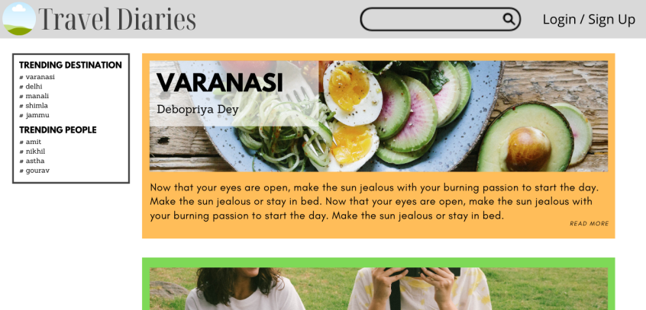

**Profile page**

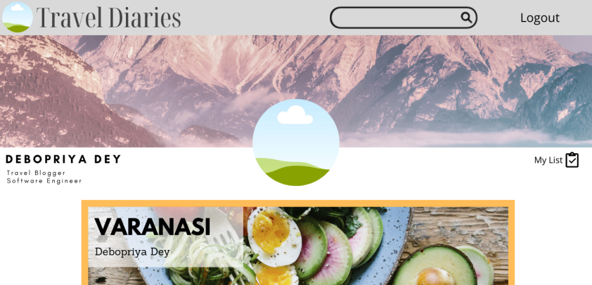

**Login page**

